RELEASE DATE | GENRE | TARGET AUDIENCE | PLAYERS | Developer | SRC | BARCODE
Sept 05 | Racing | 12-25 | 1-16 | Climax | TBC | TBC

The MotoGP series is the definitive motorcycle racing game for the Xbox and Windows. The game accurately captures the excitement of Grand Prix motorcycle racing.  This time, MotoGP 3 is taking the franchise to the extreme, expanding beyond the realms of Grand Prix racing to incorporate high adrenaline Street Racing. Players can hone their skills on the streets or progress through the Grand Prix championship. | 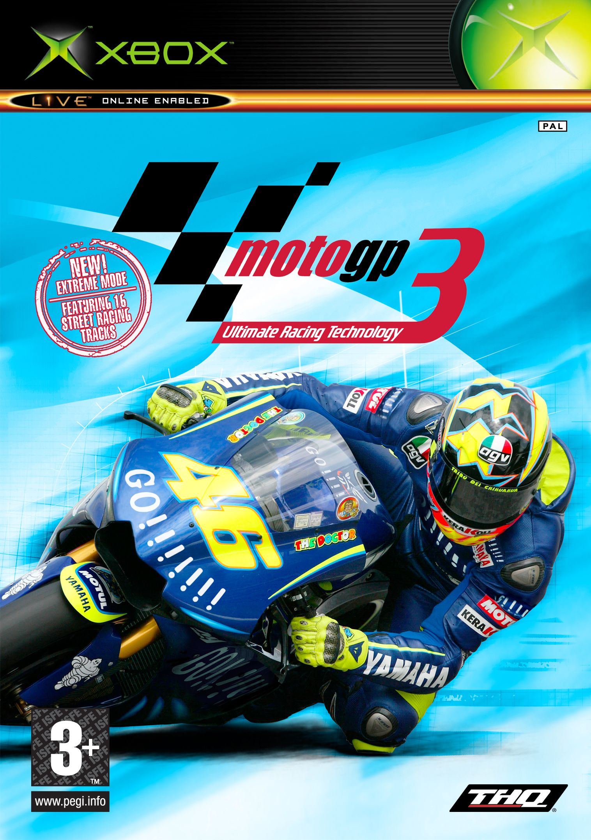

FEATURES
- Fully licensed riders, tracks and bikes from the 2004 MotoGP Season
- All new ‘Extreme’ Mode featuring 16 street racing tracks and 16 street racing bikes - Full customisation and upgrade system for street racing bikes
- Online gaming through Microsoft’s Live Service / Up to 16 online players per race
  - New online features
    - Seeding system: Seeding creates the level playing field online allowing any player to easily identify how experienced other players are.
    - Embedded Online Gameplay: As players play-through their career they will be continually have access to online version of each event. Allowing them to take their game online seamlessly at any time.
    - Spectator Mode: Assign yourself as a spectator, giving you the option of watching some of the better riders race around the track and learn some of their techniques.
    - Commentator Mode: Designated by the host of live! games, one player gets to commentate while spectating.
- 6 different game modes: Quick Race, Grand Prix Mode, Extreme Mode, Time Trial, Training Mode, Multiplayer.
- 20 riders competing in each race (10 in Extreme mode)
- 4-player split-screen multiplayer options.
- 60 frames per second.


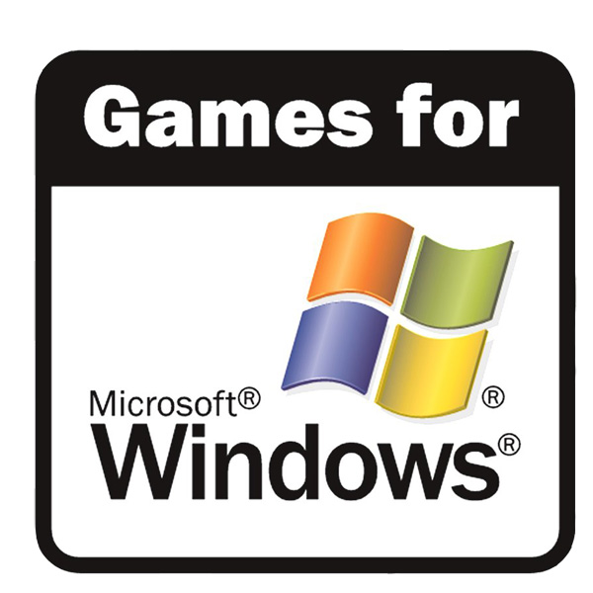
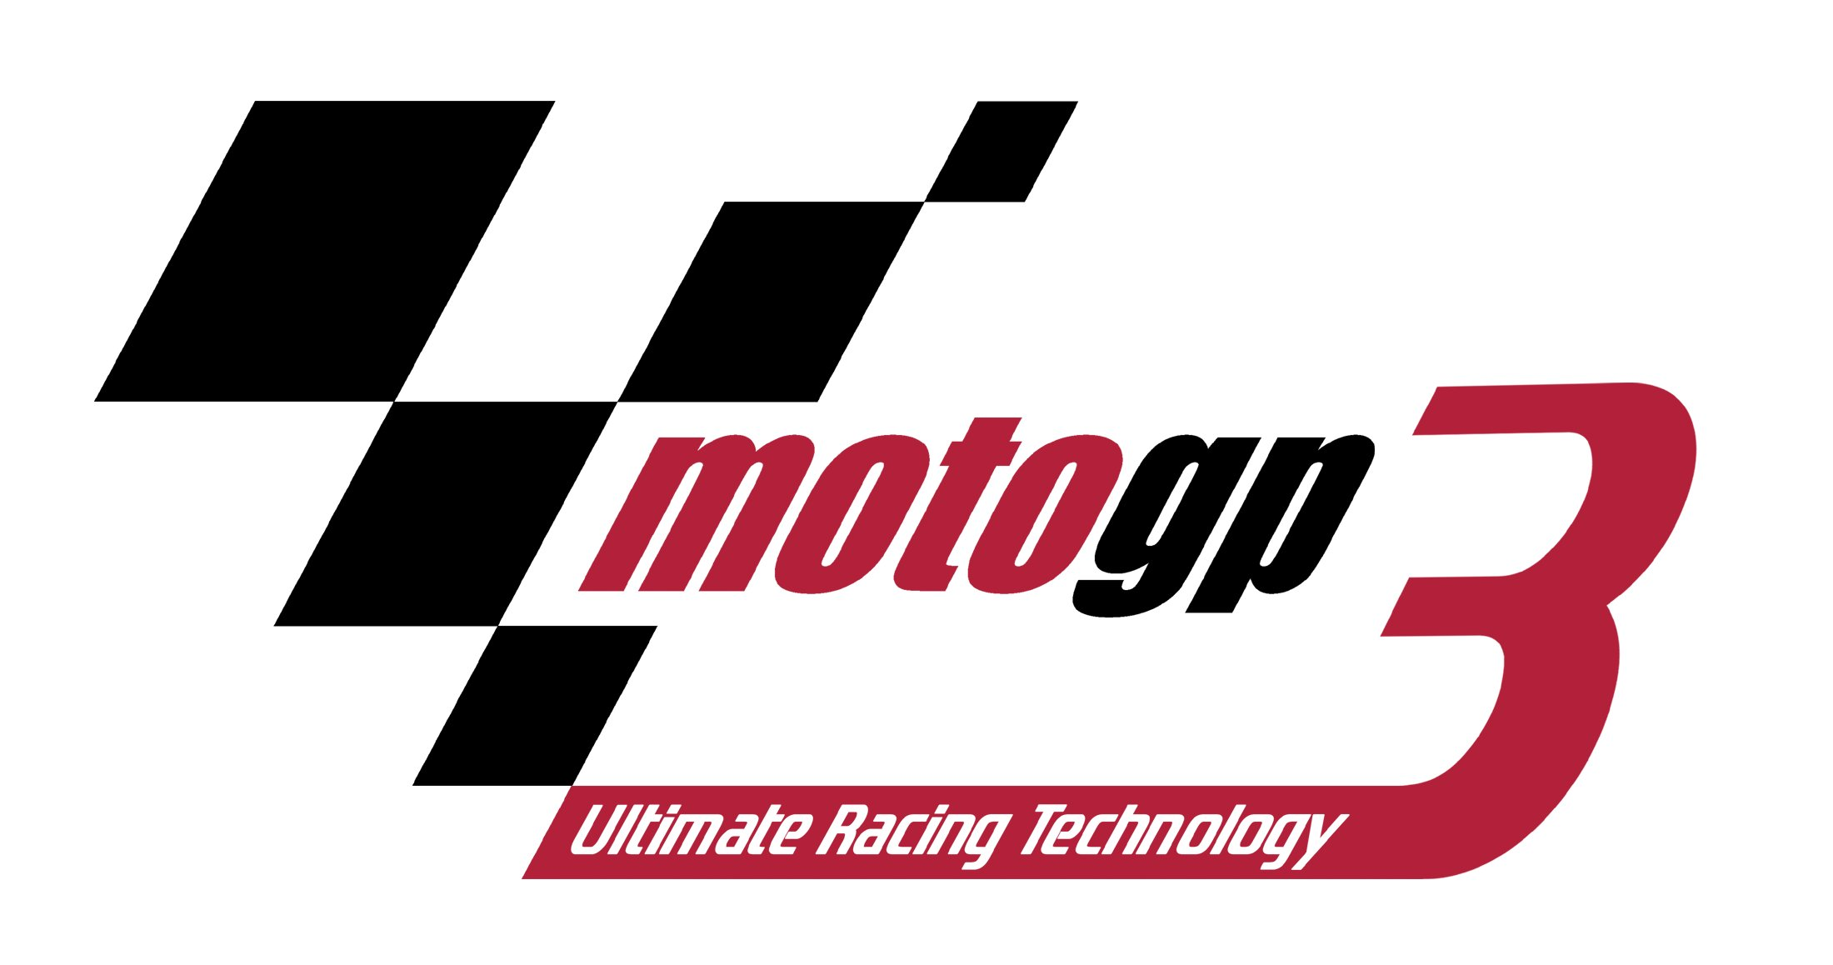
MotoGP Ultimate Racing Technology 3

